# Android App Development

## CodeIt

Note: Please use Android version 10 or above in appetize.io

## Github Link: <https://github.com/99002492/Android_Exam>

Online Emulator Link: <https://appetize.io/app/4bnfcn50me7fg286frrbk2apar>

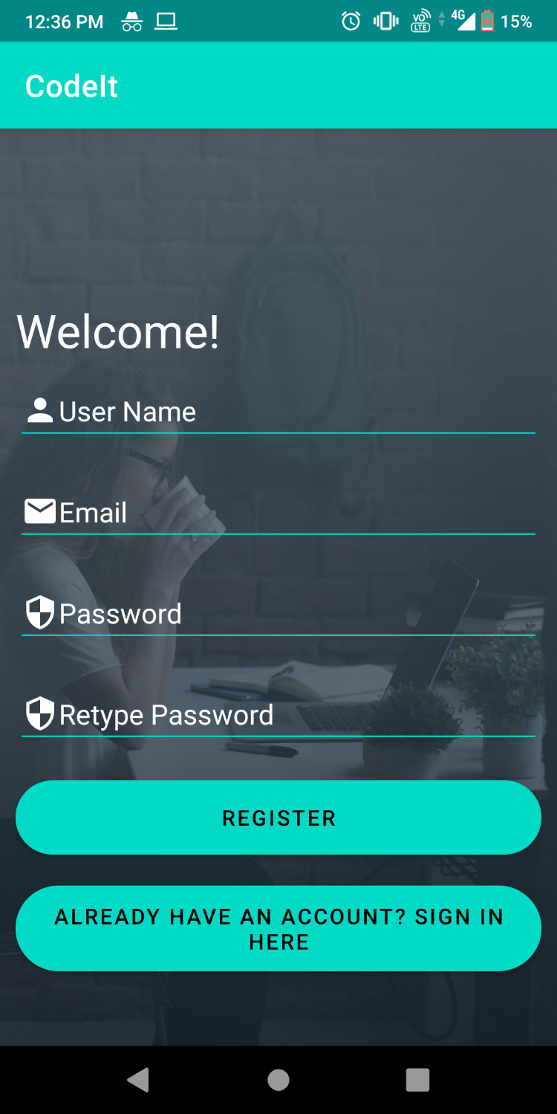

## Login

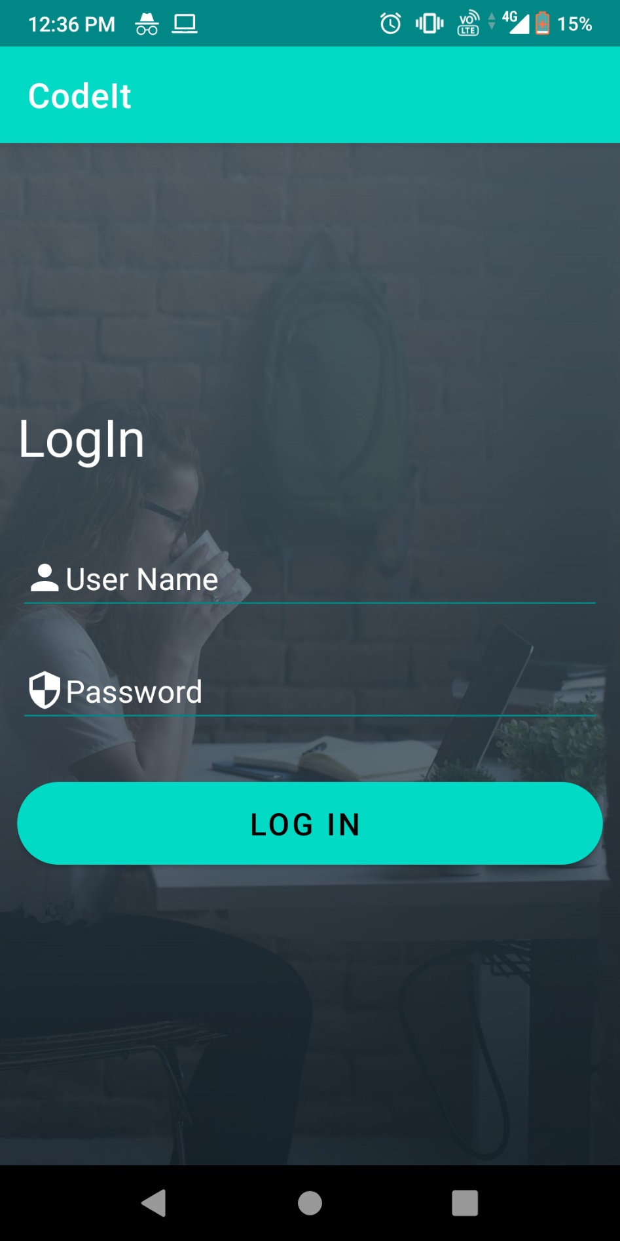

## Recycler View

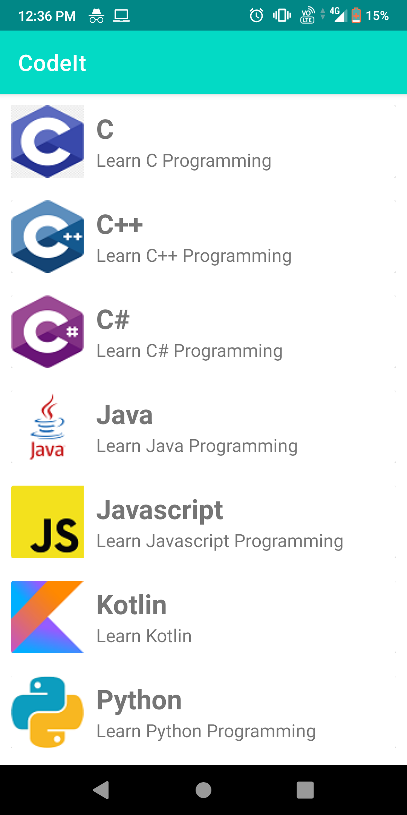

## Detail View



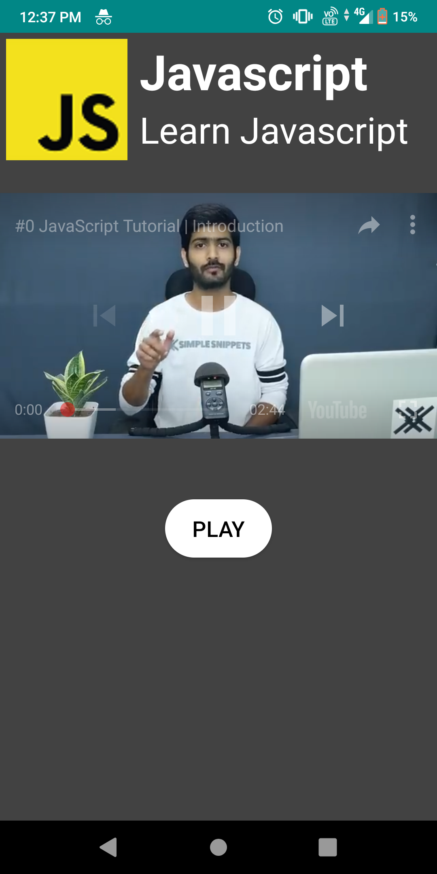

## Hindi Translation

## Register

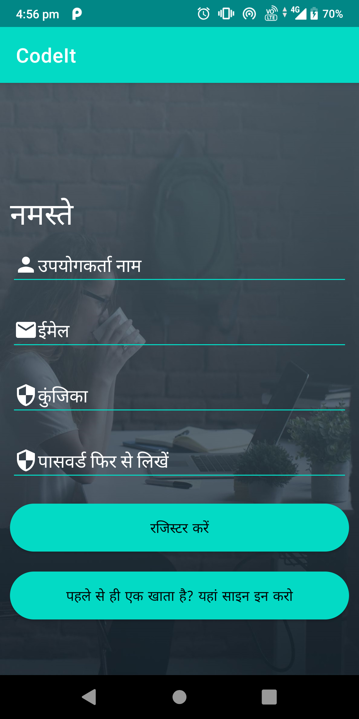

## Login

